# Download and Install **Jenkins**

Jenkins may be installed on either **Windows or Unix platforms**, but we will focus on Linux installation only.

**Prerequisites:**

Before you proceed to install Jenkins in your Linux system, there are some prerequisites for Jenkins to install Jenkins in your computer.

**Hardware requirements:**

* You need minimum 256 MB of RAM in your computer or laptop to install Jenkins
* You need at least 1 GB of space in your hard drive for Jenkins.

**Software Requirements:**

* Since Jenkins runs on Java, you need either latest version of Java Development Kit (JDK) or Java Runtime Environment (JRE).

**Release Types**

Jenkins releases two types of versions based on the organization needs.

* Long-term support release
* Weekly release

**Long term support release (LTS) :**

Long-term support releases are available every 12 weeks. They are stable and are widely tested. This release is intended for end users.

**Weekly release:**

Weekly releases are made available every week by fixing bugs in its earlier version. These releases are intended towards plugin developers.

We will use the LTS release though the process remains the same for Weekly release.

**How to Download & Install Jenkins on Linux?**

### Launch RedHat Linux

### Install Java

**For CENTOS/Redhat/Amazon Linux**

**yum install java-1.8* -y**

**cd /usr/lib/jvm/**

**Update $HOME/.bash_profile (To make it permanent)**

**export JAVA_HOME=/usr/lib/jvm/java-1.8.0-openjdk-1.8.0.252.b09-2.51.amzn1.x86_64**

**export PATH=$JAVA_HOME/bin:$PATH**

**=========================**

**source $HOME/.bash_profile**

java -version

alternatives --config java

There are 2 programs which provide 'java'.

Selection Command

-----------------------------------------------

*+ 1 /usr/lib/jvm/jre-1.7.0-openjdk.x86_64/bin/java

2 /usr/lib/jvm/jre-1.8.0-openjdk.x86_64/bin/java

Enter to keep the current selection[+], or type selection number: 2

**Script**

yum install java-1.8* -y

if [ $? -ne 0 ]; then

echo "yum install failed"

exit 1

else

cd /usr/lib/jvm/

ls -ld java-1.8.0-openjdk-1.8.0.*

if [ $? -ne 0 ]; then

echo "JAVA 1.8 not found in the JVM dir"

exit 1

else

v_java=$(ls -ld java-1.8.0-openjdk-1.8.0.* | awk '{print $9}')

echo "export JAVA_HOME=/usr/lib/jvm/$v_java" >> $HOME/.bash_profile

echo ‘export PATH=$JAVA_HOME/bin:$PATH’ >> $HOME/.bash_profile

source $HOME/.bash_profile

fi

java -version

echo 2 |alternatives --config java

echo ""

echo "JAVA 8 is installed Successfully"

fi

==============

#!/bin/bash

**check () ####### Function Defination**

**{**

**var=$2 ####### Var section**

**flag=$1**

**if [ $flag -ne 0 ]; then ####### if section**

**echo "Failed at step $var.."**

**exit 1**

**else**

**echo "Congratulations: Step $var is success.."**

**fi**

**}**

**yum install java-1.8* -y**

**check $? java_install ####### call Function**

**cd /usr/lib/jvm/**

**ls -ld java-1.8.0-openjdk-1.8.0.\***

**check $? java_dir**

**v_java=$(ls -ld java-1.8.0-openjdk-1.8.0.* | awk '{print $9}') ####### awk usage**

**echo "export JAVA_HOME=/usr/lib/jvm/$v_java" >> $HOME/.bash_profile**

**echo 'export PATH=$JAVA_HOME/bin:$PATH' >> $HOME/.bash_profile**

**source $HOME/.bash_profile**

**java -version**

**echo 2 |alternatives --config java**

**echo ""**

**echo "JAVA 8 is installed Successfully"**

**For Ubuntu**

### Download Jenkins and Install - TASK to create a Shell Script

[root@ip-172-31-40-69 ec2-user]# yum repolist

Loaded plugins: priorities, update-motd, upgrade-helper

repo id repo name status

**amzn-main/latest amzn-main-Base 5,934**

**amzn-updates/latest** amzn-updates-Base 3,452

repolist: 9,386

[root@ip-172-31-40-69 ec2-user]# sudo wget -O /etc/yum.repos.d/jenkins.repo http://pkg.jenkins-ci.org/redhat-stable/jenkins.repo

--2020-01-05 13:14:45-- http://pkg.jenkins-ci.org/redhat-stable/jenkins.repo

Resolving pkg.jenkins-ci.org (pkg.jenkins-ci.org)... 52.202.51.185

Connecting to pkg.jenkins-ci.org (pkg.jenkins-ci.org)|52.202.51.185|:80... connected.

HTTP request sent, awaiting response... 200 OK

Length: 85

Saving to: ‘/etc/yum.repos.d/jenkins.repo’

/etc/yum.repos.d/jenkins.repo 100%[====================================================================================================>] 85 --.-KB/s in 0s

2020-01-05 13:14:46 (15.0 MB/s) - ‘/etc/yum.repos.d/jenkins.repo’ saved [85/85]

[root@ip-172-31-40-69 ec2-user]# yum repolist

Loaded plugins: priorities, update-motd, upgrade-helper

jenkins | 2.9 kB 00:00:00

jenkins/primary_db | 30 kB 00:00:00

repo id repo name status

amzn-main/latest amzn-main-Base 5,934

amzn-updates/latest amzn-updates-Base 3,452

jenkins Jenkins-stable 96

repolist: 9,482

[root@ip-172-31-40-69 ec2-user]# sudo rpm --import <https://pkg.jenkins.io/redhat-stable/jenkins.io.key>

[root@ip-172-31-40-69 ec2-user]# sudo yum install jenkins -y

Loaded plugins: priorities, update-motd, upgrade-helper

Resolving Dependencies

--> Running transaction check

---> Package jenkins.noarch 0:2.204.1-1.1 will be installed

--> Finished Dependency Resolution

Dependencies Resolved

=============================================================================================================================================================================================

Package Arch Version Repository Size

=============================================================================================================================================================================================

Installing:

jenkins noarch 2.204.1-1.1 jenkins 60 M

Transaction Summary

=============================================================================================================================================================================================

Install 1 Package

Total download size: 60 M

Installed size: 61 M

Is this ok [y/d/N]: y

Downloading packages:

jenkins-2.204.1-1.1.noarch.rpm | 60 MB 00:00:32

Running transaction check

Running transaction test

Transaction test succeeded

Running transaction

Installing : jenkins-2.204.1-1.1.noarch 1/1

Verifying : jenkins-2.204.1-1.1.noarch 1/1

Installed:

jenkins.noarch 0:2.204.1-1.1

Complete!

[root@ip-172-31-40-69 java-1.8.0-openjdk-1.8.0.222.b10-0.47.amzn1.x86_64]# service jenkins start

Starting Jenkins [ OK ]

[root@ip-172-31-40-69 java-1.8.0-openjdk-1.8.0.222.b10-0.47.amzn1.x86_64]#

Other Method

[root@ip-172-31-47-114 jenkins]# **wget http://mirrors.jenkins.io/war-stable/latest/jenkins.war**

--2020-01-05 10:39:30-- http://mirrors.jenkins.io/war-stable/latest/jenkins.war

Resolving mirrors.jenkins.io (mirrors.jenkins.io)... 52.202.51.185

Connecting to mirrors.jenkins.io (mirrors.jenkins.io)|52.202.51.185|:80... connected.

HTTP request sent, awaiting response... 302 Found

Location: http://ftp-chi.osuosl.org/pub/jenkins/war-stable/2.204.1/jenkins.war [following]

--2020-01-05 10:39:31-- http://ftp-chi.osuosl.org/pub/jenkins/war-stable/2.204.1/jenkins.war

Resolving ftp-chi.osuosl.org (ftp-chi.osuosl.org)... 64.50.236.52, 2600:3402:200:227::2

Connecting to ftp-chi.osuosl.org (ftp-chi.osuosl.org)|64.50.236.52|:80... connected.

HTTP request sent, awaiting response... 200 OK

Length: 63433755 (60M) [application/x-java-archive]

Saving to: ‘jenkins.war’

jenkins.war 100%[====================================================================================================>] 60.50M 1.67MB/s in 34s

**2020-01-05 10:40:05 (1.78 MB/s) - ‘jenkins.war’ saved [63433755/63433755]**

**[root@ip-172-31-47-114 jenkins]# nohup java -jar jenkins.war --httpPort=8080 &**

Running from: /home/ec2-user/jenkins/jenkins.war

webroot: $user.home/.jenkins

*************************************************************

*************************************************************

*************************************************************

Jenkins initial setup is required. An admin user has been created and a password generated.

Please use the following password to proceed to installation:

a219e902ade04b8da0072a4313ae4448

This may also be found at: **/root/.jenkins/secrets/initialAdminPassword**

*************************************************************

*************************************************************

*************************************************************

--

--

2020-01-05 12:29:51.228+0000 [id=25] INFO jenkins.InitReactorRunner$1#onAttained: Completed initialization

2020-01-05 12:29:51.261+0000 [id=19] INFO hudson.WebAppMain$3#run: Jenkins is fully up and running

Open a Duplicate session –

[root@ip-172-31-47-114 ec2-user]# curl ifconfig.co

15.206.145.30

**Open a browser - 15.206.145.30:8080**

**For Ubuntu**

**https://pkg.jenkins.io/debian/**

**Jenkins Debian Packages**

**This is the Debian package repository of Jenkins to automate installation and upgrade. To use this repository, first add the key to your system:**

**WARNING: The gpg key use to sign our packages has been updated on 16th of April 2020, therefore you need to reimport it if you imported before this date.**

**wget -q -O - https://pkg.jenkins.io/debian/jenkins.io.key | sudo apt-key add -**

**Then add the following entry in your /etc/apt/sources.list:**

**deb https://pkg.jenkins.io/debian binary/**

**Update your local package index, then finally install Jenkins:**

**sudo apt-get update**

**sudo apt-get install jenkins**

**Use DOCKER**

**docker run -it -d –name=Jenkins jenkins**

### Open Jenkins Page

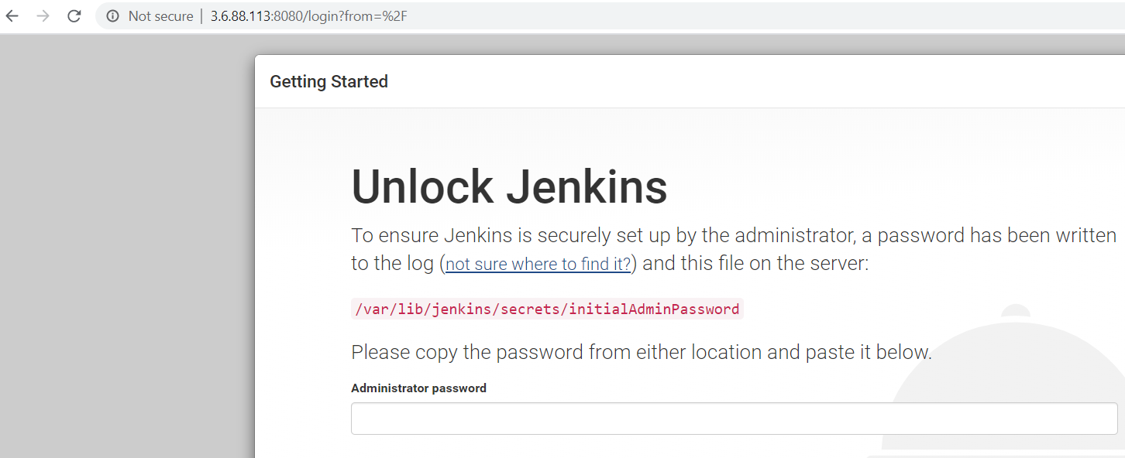

Provide password from the file - /var/lib/jenkins/secrets/initialAdminPassword and continue

### Install default plugins

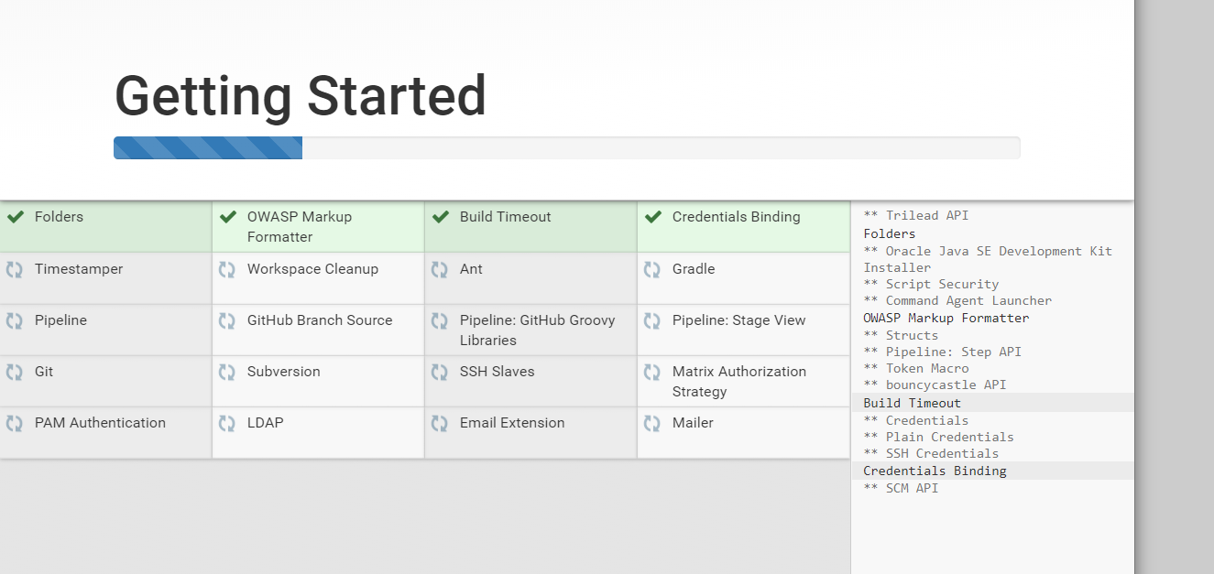

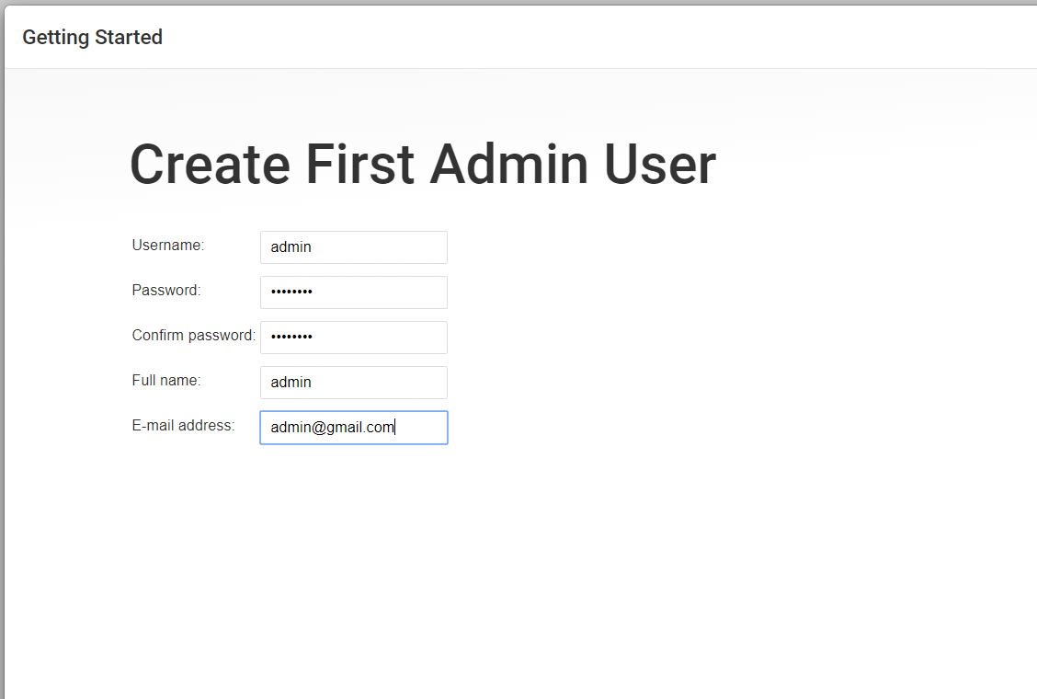

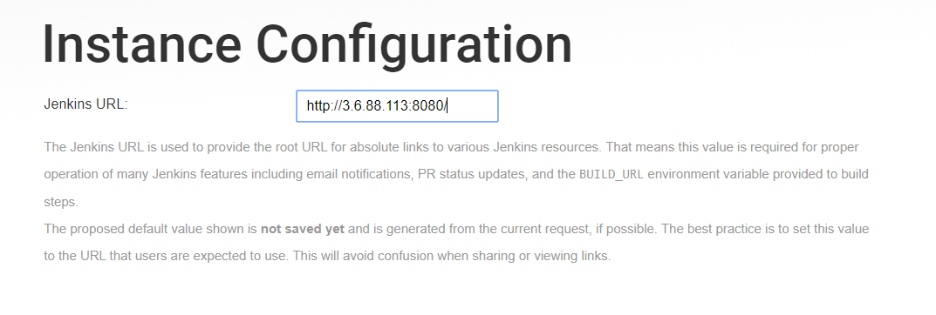

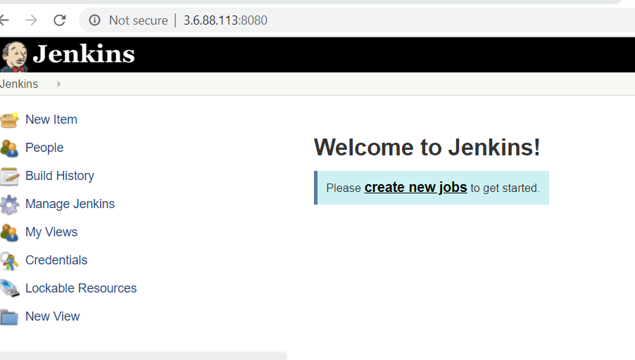

**How to Download Jenkins on Windows?**

Following steps should be followed so that to install Jenkins successfully:

**Step 1)** Got to <https://jenkins.io/download/> and select the platform. In our case Windows

[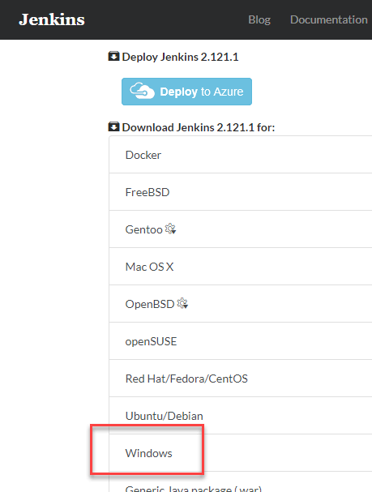](https://www.guru99.com/images/1/063018_1023_HowtoDownlo1.png)

**Step 2)** Go to download location from local computer and unzip the downloaded package. Double-click on unzipped **jenkins.msi**. You can also Jenkin using a WAR (Web application ARchive) but that is not recommended.

[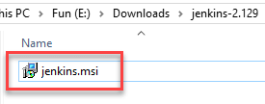](https://www.guru99.com/images/1/063018_1023_HowtoDownlo2.png)

**Step 3)** In the Jenkin Setup screen, click Next.

[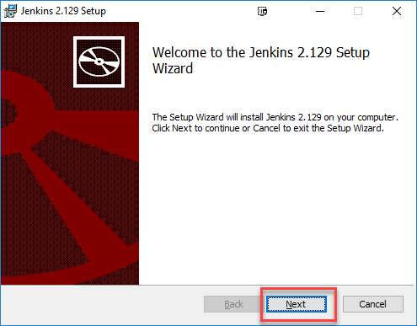](https://www.guru99.com/images/1/063018_1023_HowtoDownlo3.png)

**Step 4)** Choose the location where you want to have the Jenkins instance installed (default location is C:\Program Files (x86)\Jenkins), then click on **Next** button.

[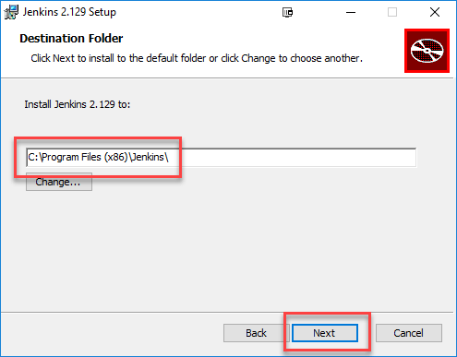](https://www.guru99.com/images/1/063018_1023_HowtoDownlo4.png)

**Step 5)**Click on the Install button.

[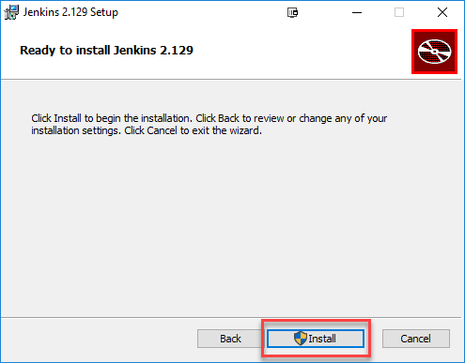](https://www.guru99.com/images/1/063018_1023_HowtoDownlo5.png)

**Step 6)** Once install is complete, click Finish.

[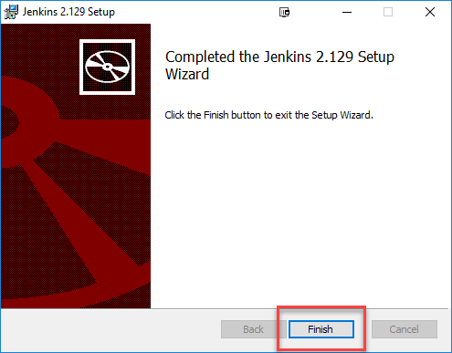](https://www.guru99.com/images/1/063018_1023_HowtoDownlo6.png)

**Step 7)** During the installation process an info panel may pop-up to inform the user that for a complete setup, the system should be rebooted at the end of the current installation. Click on OK button when the Info panel is popping-up:

[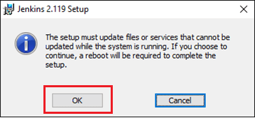](https://www.guru99.com/images/1/063018_1023_HowtoDownlo7.png)

**How to Unblock Jenkins?**

After completing the Jenkins installation phase, you should proceed further and start its configuration. Next steps will guide you how you can unblock Jenkins application:

**Step 1)** After completing the Jenkins installation process, a browser tab will pop-up asking for the initial Administrator password. To access Jenkins, you need to go to browse the following path in your web browser.

http://localhost:8080

If you can access the above URL, then it confirms that Jenkins is successfully installed in your system.

[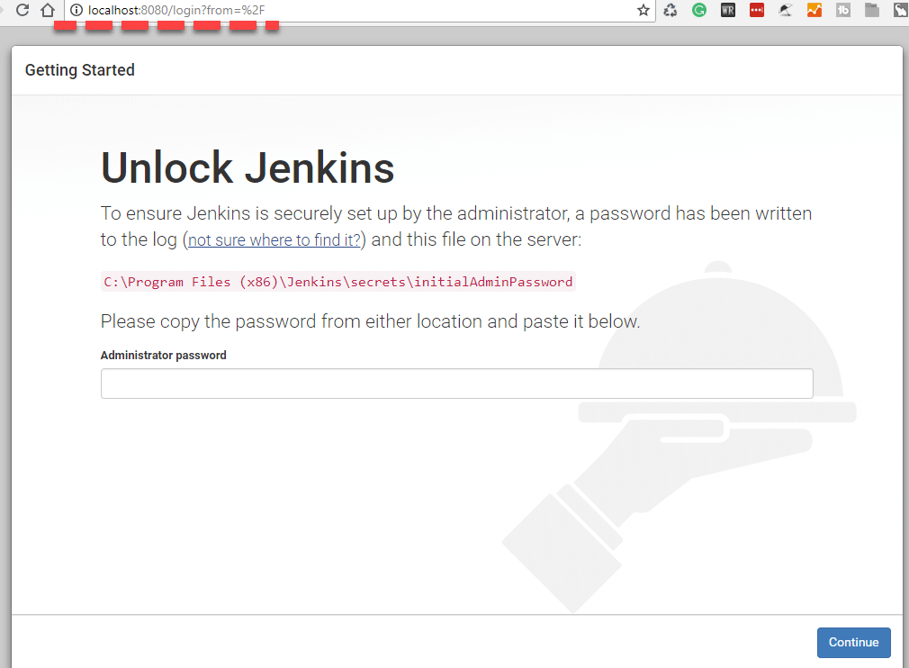](https://www.guru99.com/images/1/063018_1023_HowtoDownlo8.png)

**Step 2)** The initial Administrator password should be found under the Jenkins installation path (set at Step 4 in Jenkins Installation).

For default installation location to C:\Program Files (x86)\Jenkins, a file called **initialAdminPassword** can be found under C:\Program Files (x86)\Jenkins\secrets.

However, If a custom path for Jenkins installation was selected, then you should check that location for **initialAdminPassword** file.

[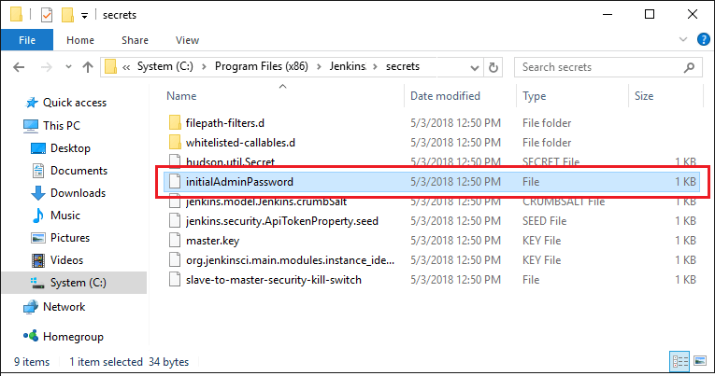](https://www.guru99.com/images/1/063018_1023_HowtoDownlo9.png)

**Step 3)** Open the highlighted file and copy the content of the **initialAdminPassword**file.

[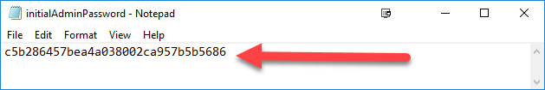](https://www.guru99.com/images/1/063018_1023_HowtoDownlo10.png)

**Step 4)** Paste the password it into browser's pop-up tab (<http://localhost:8080/login?form=%2F>) and click on Continue button.

[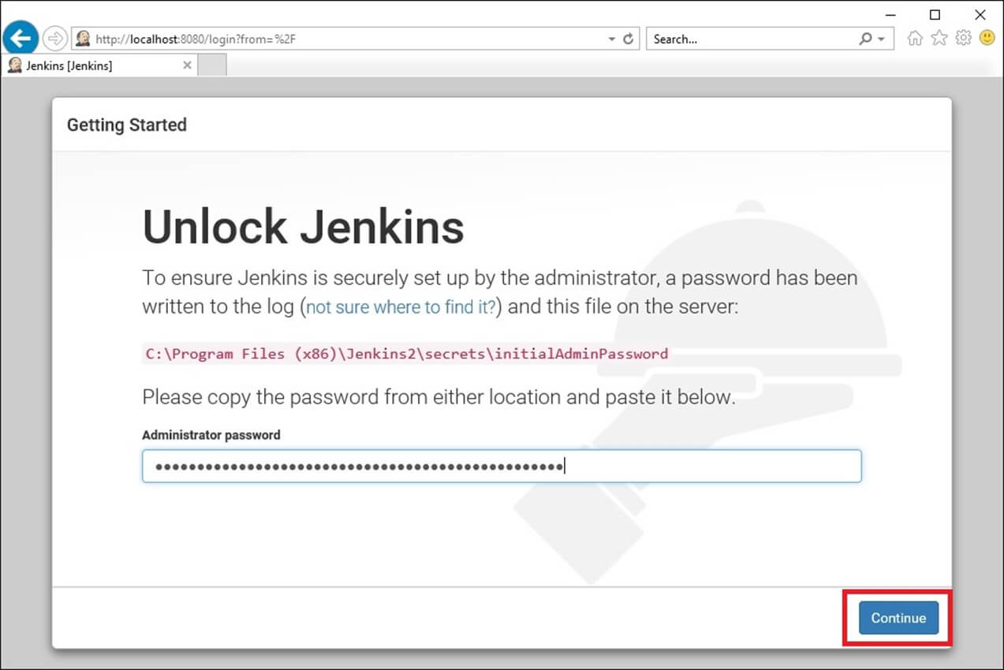](https://www.guru99.com/images/1/063018_1023_HowtoDownlo11.jpg)

**Customize Jenkins**

You can also customize your Jenkins environment by below-given steps:

**Step 1)** Click on the "Install suggested plugins button" so Jenkins will retrieve and install the essential plugins

[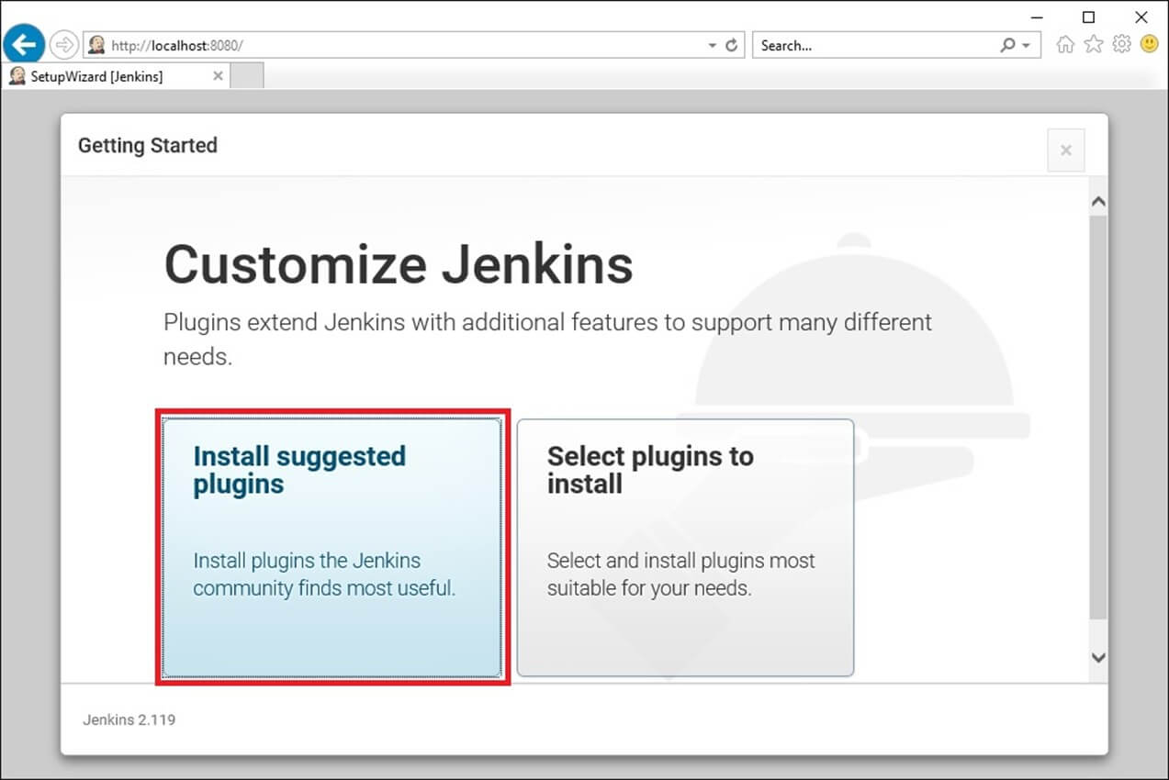](https://www.guru99.com/images/1/063018_1023_HowtoDownlo12.jpg)

Jenkins will start to download and install all the necessary plugins needed to create new Jenkins Jobs.

[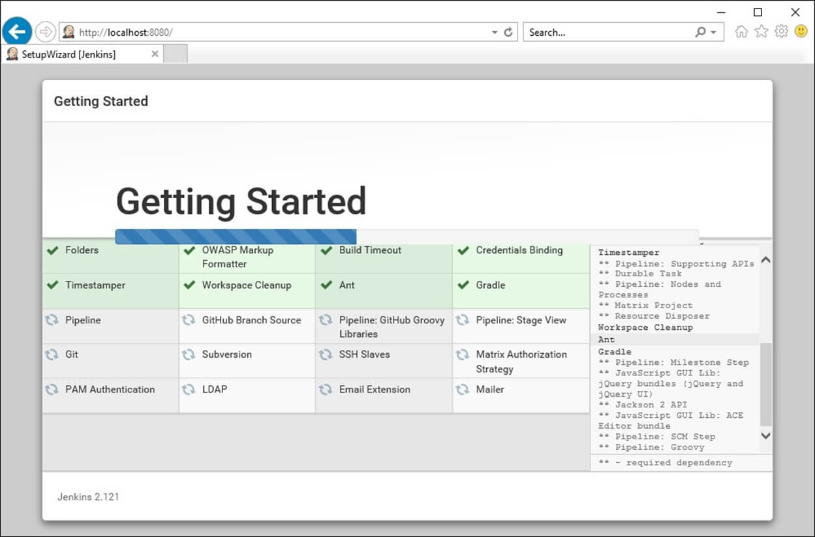](https://www.guru99.com/images/1/063018_1023_HowtoDownlo13.jpg)

**Note**: You can choose the Option "Select Plugins to Install" and select the plugins you want to install

[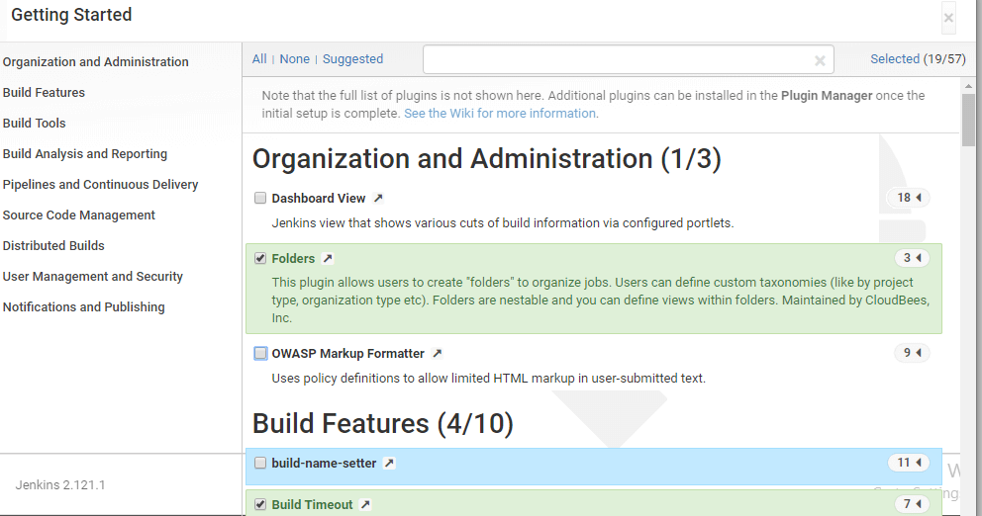](https://www.guru99.com/images/1/063018_1023_HowtoDownlo14.png)

**Step 2)** After all suggested plugins were installed, the "Create First Admin User" panel will show up. Fill all the fields with desired account details and hit the "**Save and Finish**" button.

[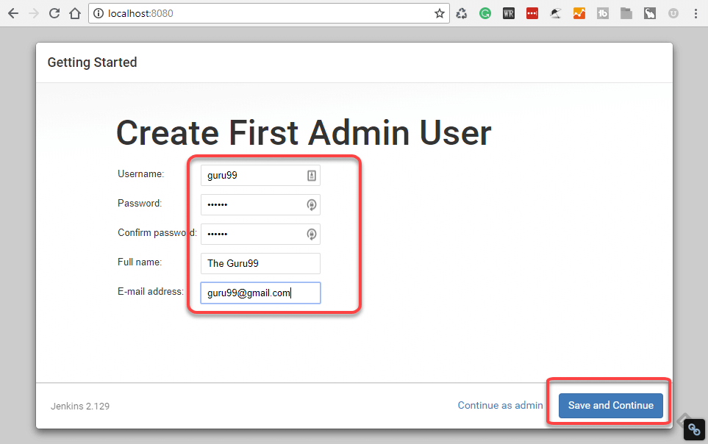](https://www.guru99.com/images/1/063018_1023_HowtoDownlo15.png)

**Step 3)**Once you have filled the above data, finally it will ask for URL information where you can configure the default instance path for Jenkins. Leave it as it is to avoid any confusions later. However, if another application is already using 8080 port, you can use another port for Jenkins and finally save the settings, and you are done with installation of Jenkins. Hit the "**Save and Continue**" button:

[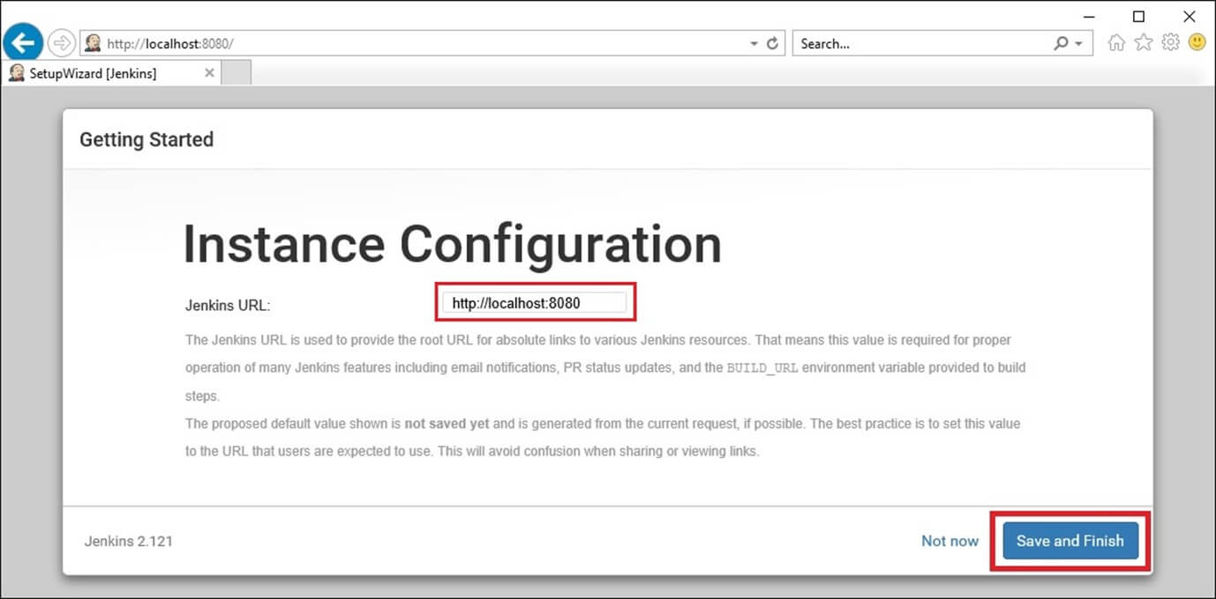](https://www.guru99.com/images/1/063018_1023_HowtoDownlo16.jpg)

Congratulations! We have successfully installed a new Jenkins Server. Hit the "Start using Jenkins" button.

[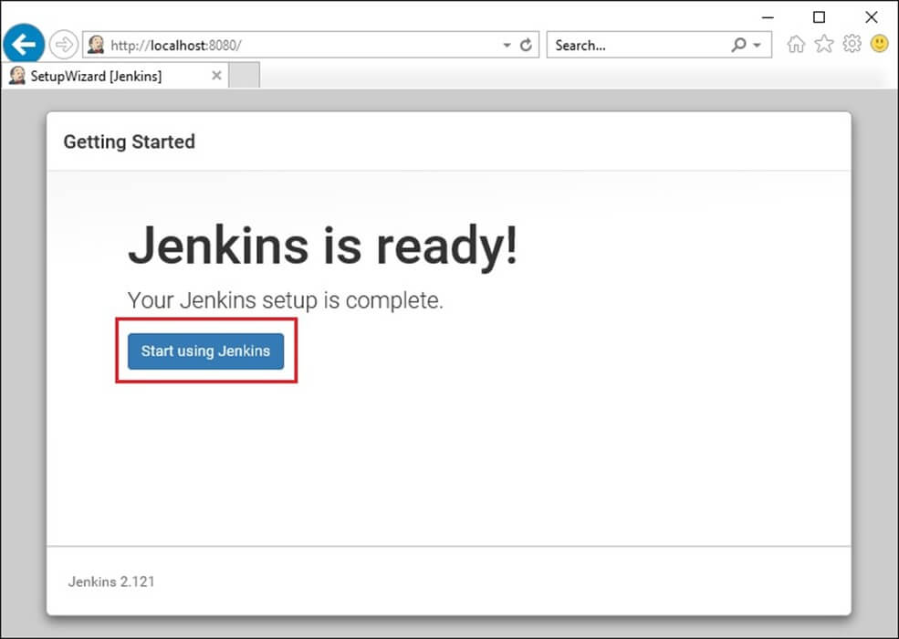](https://www.guru99.com/images/1/063018_1023_HowtoDownlo17.jpg)

Below you can find the Jenkins instance up and run, ready to create first Jenkins jobs:

[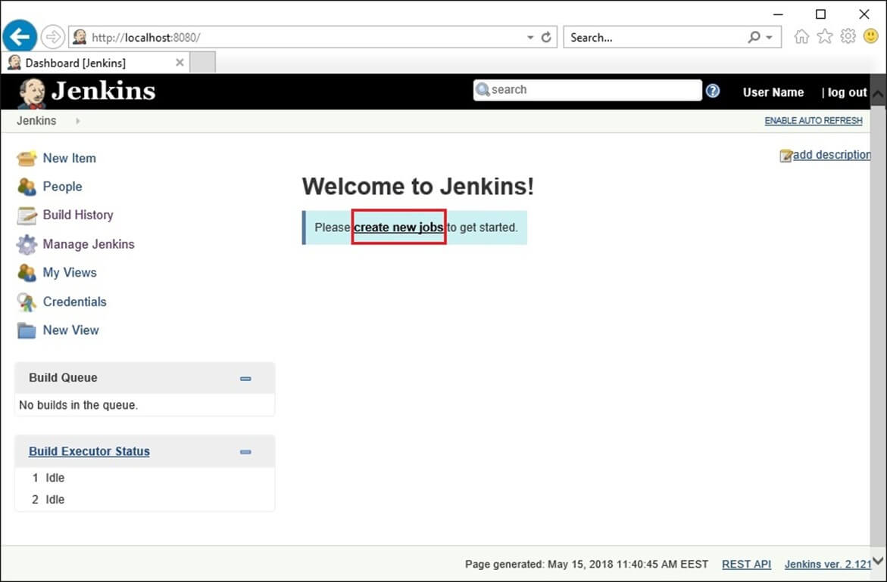](https://www.guru99.com/images/1/063018_1023_HowtoDownlo18.jpg)

## Manage Jenkins 🡪 Global Tool Configuration

### Java Path

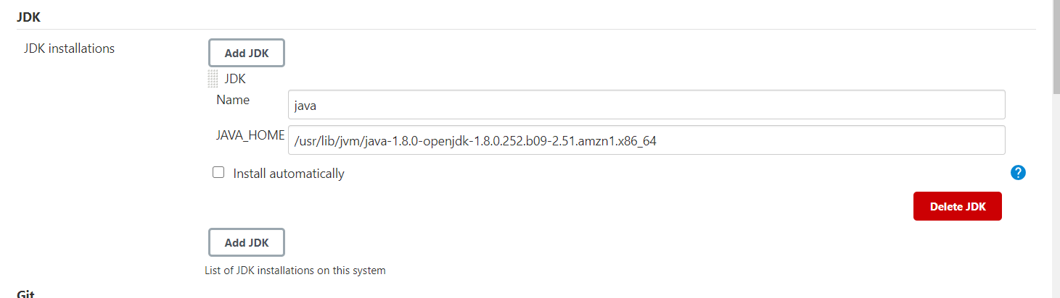

### Maven path

### Git Path

Install git in your Jenkins server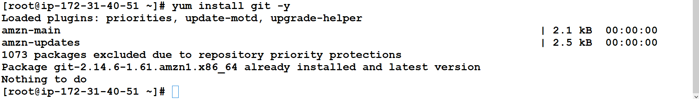

Go to manage Jenkins and set it

